Here is the Title
John Doe^{1,*} and Jane Smith^{1,2,*}
¹Department of Chemistry, Faculty of Arts and Sciences, Beĳing Normal University, Zhuhai 519087, China
²College of Chemistry, Beĳing Normal University, Beĳing 100875, China
*Corresponding authors: xxxxx@xxx
Received: 20 Oct. 2026; Revision: 25 Oct. 2026; Accepted: 25 Dec. 2026; Online: 28 Dec. 2026

Abstract: The abstract should be a single paragraph that summarises the content of the article.
Key words: tunneling, semiclassical, rate theory, quantization.

The main text of the article should appear here. The references should be cited as [1–8].
The time-dependent Schrödinger equation is:
All figures and tables must be mentioned in the text consecutively and numbered with Arabic numerals, such as Figure 1 or Table 1.
Table 1. Each table must have a brief (one phrase or sentence) title that describes its contents.
Head 1^{[a]} | Head 2 | Head 3 | Head 4
Column 1 | Column 2^{[b]} | Column 3 | Column 4
Column 1 | Column 2 | Column 3 | Column 4
Column 1 | Column 2 | Column 3 | Column 4
[a] Table footnote. [b] Table footnote.
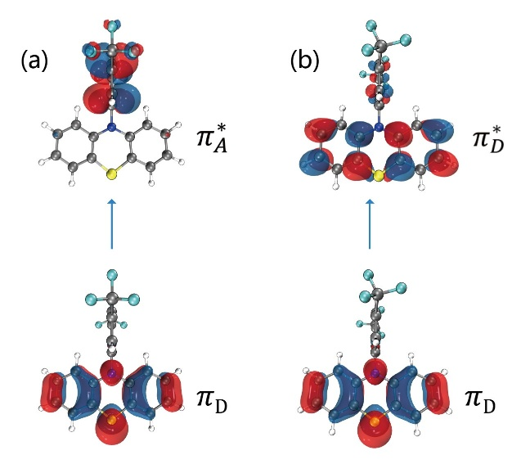
Figure 1. Each figure must have a caption that includes the figure number and a brief description, preferably one or two sentences.

Acknowledgments
Here is the place to acknowledge people, organizations, and financing (you may state grant numbers and sponsors here).

Supporting information
The online version contains supplementary material available at website xxx. A listing of the contents of each file supplied as Supporting Information should be included.

Notes
The authors declare no competing financial interest.

References
[1] Berger M. J. and Colella P., Local adaptive mesh refinement for shock hydrodynamics, J. Comput. Phys., 82 (1989), 62–84.
[2] Tan Z. J., Tang T. and Zhang Z. R., A simple moving mesh method for one- and two-dimensional phase-field equations, J. Comput. Appl. Math., To appear.
[3] McKechnie S., Frost J. M., Pashov D., Azarhoosh P., Walsh A. and Schilfgaarde M., Dynamic symmetry breaking and spin splitting in metal halide perovskites, 2017, DOI: 10.48550/arXiv.1711.00533.
[4] de Boor C., Good approximation by splines with variable knots II, In Springer Lecture Notes Series 363, SpringerVerlag, Berlin, 1973.
[5] Tullius T. D., Supramolecular reactivity and transport: Bioinorganic systems, In Comprehensive Supramolecular Chemistry, Vol. 5, (Eds. Atwood J. L., Davies J. E. D., MacNicol D. D., Vögtle F. and Suslick K. S.), Pergamon, Oxford, 1996, pp. 317–343.
[6] Doe J., Dataset title, Year, DOI: persistent identifier (e.g. DOI).
[7] Sheldrick G. M., SHELXS-96, program for the solution of crystal structures, University of Göttingen, Göttingen, Germany, 1996.
[8] Tullius T. D., Title of PhD thesis, University of Newcastle, UK, 1991.

